**Technical Report _Mental Health Analysis Report for Hallmark University**

1. INTRODUCTION

Mental Health in Higher Education — A Crisis Beneath the Surface

In recent years, universities across the globe have witnessed a silent but deeply concerning trend: the deterioration of student mental health. While academic performance, credit load, and graduation rates often dominate institutional metrics, the mental and emotional well-being of students is an equally vital, yet often neglected component of student success.

To address this concern, I conducted a comprehensive Mental Health Analysis leveraging institutional data. This analysis covered a broad range of indicators, including:

* Depression and anxiety scores
* Academic credit loads
* CGPA contributions
* Stress levels by relationship status
* Course-specific mental health impacts
* Gender-based performance distribution

The results are sobering and offer a clear message: mental health issues are highly correlated with age, academic load, relationship status, and program of study. This is not merely an issue of personal resilience — it’s a systemic challenge rooted in how we structure the student experience.

2. STORY OF DATA

The data is telling the story of different factors that contribute to the mental health of university students. The data contain information of the age, course and gender of the students, it also provide information on mental scores, social support, lifestyle activities, and other factors that could contribute to mental health positively or negatively.

3. DATA SPLITTING AND PROCESSING

The data was split into two categories. Dependent values (values that can not stand on their own) and Independent values (values that can stand on their own).

Category one : Independent values

Age

Course

Gender

Category two : Dependent values

CGPA

Stress Level

Depression Score

Anxiety Score

Sleep Quality

Physical Activity

Diet-Quality

Social-Support

Relationship Status

Substance Use

Family History

Industry Type Of Data

This data belong survey carried out on Mental Health, the health parameters provided by the data is important for setting up interventions to help reduced mental health among university students Stakeholders Of Project The key stakeholders here are the School management, health sector and state ministry of health. What success means to this industry Success for these stakeholders would be a reduction of mental health issues within the university and among this group of individuals. Having interventions that will positively improve mental health is key for these stakeholders.

4. PRE ANALYSIS

Potential Analysis/Questions

* Relation status effect on stress level
* How does semester credit load spread within the different courses?
* Estimate the cumulative score of anxiety within the different courses
* Age contribution to Depression score
* How does the gender fair in the different residence types?
* Age contribution to stress level
* CGPA distribution within the different courses
* CGPA distribution by gender.
* Gender with the best sleep quality
* Gender with the best physical activity
* Gender with the best diet quality
* Financial stress contribution to mental health
* Does family history pre disposes a student to mental health?
* Does Seeking social support and counselling services positively reduce mental health
* Substances use and mental health

5. IN ANALYSIS

Analysis Observations

* The age group with the highest stress level were those between 18–19 years of age.
* In terms of CGPA, the male ( 50.41%) folks slightly performed better than the female(49.59%) folks
* Medical Students had the largest semester credit load (48,635), this might contribution to increased stress level in this group of students
* In term of stress level, the age group 18–22 year were attributed to the highest stress level
* Majority of student live off campus and on campus, this might have distinct contribution to their stress level.
* Law and Medical courses demonstrated high academic performance by having the highest CGPA.
* The two courses also show the highest anxiety proportion, with might ties anxiety to course workload.

In Analysis Insights

* The university could consider distributing the semester credit load in Law and Medicals course to reduce the stress level and anxiety score of this group of students.
* Create social support for single students who show the highest stress level due to relationship status.
* The university should expand its counseling services to ensure the student get adequate support all through their stay at the university.
* Mentorship programs could help students with the age group of 18–19 and 20–21 cope with stress during their early year in the university

6. POST ANALYSIS AND INSIGHTS KEY FINDINGS;

* Students aged 18–21 exhibit the highest levels of anxiety and depression, likely due to transitional stress and lack of support in early college years.
* Medical students have the highest semester credit load (46,365 credits cumulatively) and the highest depression scores, indicating academic overload as a primary stressor.
* Law students report the highest anxiety rates (27.72%), followed closely by medical students (27.09%).
* Single students experience more stress (8,680 cumulative score) compared to students in relationships (5,023) or married (3,346), pointing to the importance of emotional and social support systems.
* Despite the pressure, female and male students perform almost equally well in CGPA contributions, indicating the stress burden is equally distributed across genders.

7. DATA VISUALIZATION AND CHARTS

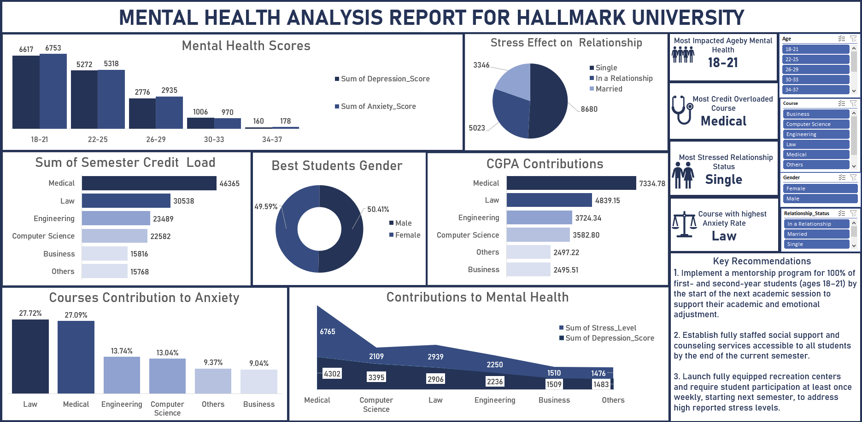

CHARTS

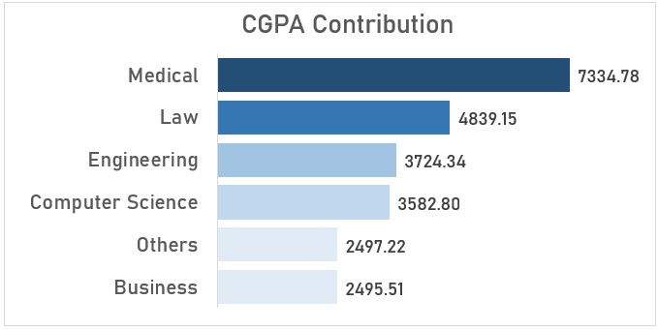

This bar chart shows the count of CGPA contribution, showing medical student with the highest count of 7334.78, followed by law students.

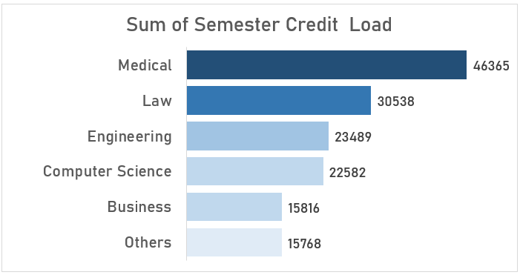This bar chart shows the sum of semester credit load by department, showing medical student with the highest load of 46365.

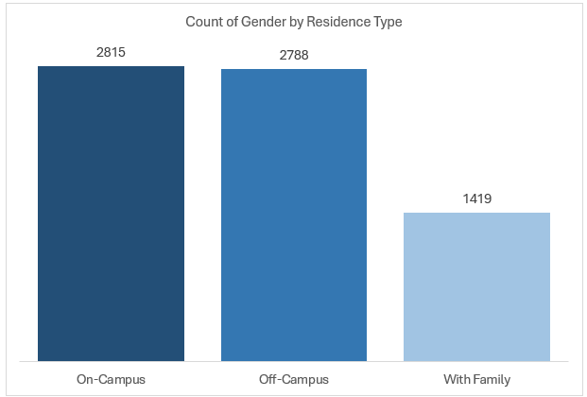This column chart shows the count of gender by residence type, showing on-campus with the highest count of 2815, followed by off-campus.

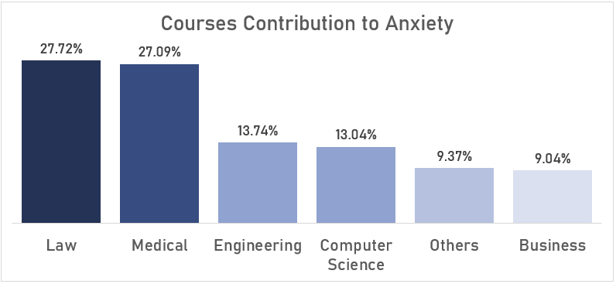This column chart shows the courses contribution to anxiety, showing law as the course with the highest anxiety rate of 27.72%.

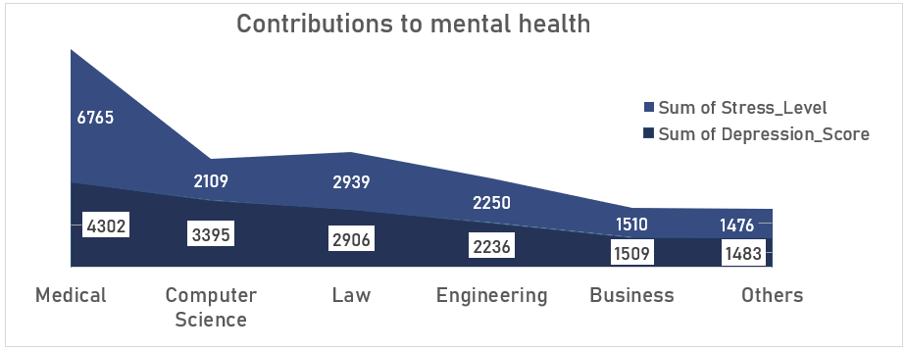This line chart shows the contribution to mental health, showing medical with the highest rate of 4302, followed by computer science with a number of 3395.

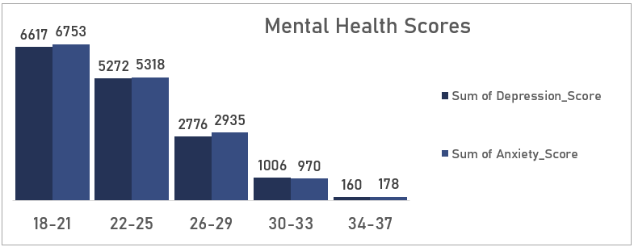 This bar chart shows the mental health score by age, showing age 18–21 with the highest score of 6617, 6753.

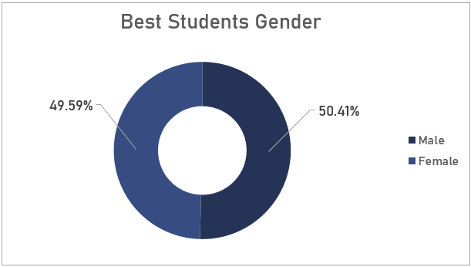 The pie chart shows the best students by gender, showing female as the best student with a number of 49.59%.

8. RECOMMENDATIONS

Here are strategic, actionable recommendations tailored to the university’s academic and mental health ecosystem:

1. Establish a Structured Mentorship Program for 100% of First- and Second-Year Students

* Why? Students aged 18–21 are the most vulnerable, with the highest anxiety and depression scores.
* What to do: Match each freshman and sophomore with trained peer mentors and faculty advisors to support their academic and emotional transition.
* Outcome: Improved retention, smoother adaptation, and early identification of students at risk.

2. Build and Fully Staff Campus Mental Health Centers

* Why? Medical and law students show high levels of anxiety and depression, and single students report the most stress. Access to trained counselors is non negotiable.
* What to do: Expand the number of licensed therapists, offer drop-in mental health clinics, and include after-hours support.
* Outcome: Decreased clinical symptoms of anxiety/depression and improved student functioning.

3. Launch Holistic Student Wellness & Recreation Centers

* Why? Recreational activities reduce cortisol and promote resilience.
* What to do: Introduce weekly fitness programs, yoga sessions, meditation workshops, and group therapy initiatives.
* Outcome: Lowered reported stress levels, stronger sense of community, better academic performance.

4. Audit and Adjust Course Credit Loads

* Why? Medical and law programs carry significantly heavier credit burdens than others. Overload leads to burnout.
* What to do: Review curriculum to identify opportunities to balance load across semesters, and introduce optional pass/fail modules for non-core subjects.
* Outcome: Better work-life balance for students, without compromising academic rigor.

5. Develop a Relationship Support & Social Belonging Program

* Why? Single students experience the most stress, indicating the protective value of social support.
* What to do: Create community groups, friendship-building activities, and support groups for students navigating loneliness and isolation.
* Outcome: Reduced isolation, improved coping skills, and higher emotional intelligence.

6. Implement a Real-Time Mental Health Monitoring System

• Why? Early detection is key to preventing crisis situations.

* What to do: Use student surveys, feedback loops, and AI-powered mood tracking apps to monitor mental health across cohorts.
* Outcome: Data-driven interventions, faster response times, and long-term well being trends tracking.

9. Conclusion: A Call for Proactive Institutional Responsibility

Hallmark University’s data reveals a deep interconnection between student success and mental health. Institutions can no longer afford to treat well-being as an extracurricular matter. These findings should catalyze a cultural and structural shift, one that centers student wellness as a foundational pillar of academic excellence. By making data-informed decisions, we can create a campus environment where thriving, not just surviving is the norm.

10. REFERENCE The dataset was gotten from [https://www.kaggle.com](https://www.kaggle.com/)